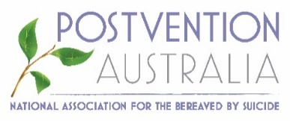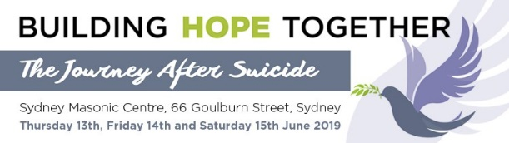

MEDIA STATEMENT
Embargoed 0500hrs 18 June 2019

Government strongly urged to Act Now as
more Australians are lost to Suicide each day say Experts

SYDNEY, Australia It was the world’s largest ever multi-day gathering of suicide loss experts. A Conference held in Australia, a nation whose recently elected federal Coalition promised with money and political will, to dramatically reduce the burgeoning rates of suicide in one of the ‘luckiest’ countries and wealthiest economies in the world.

Prioritising Mental Health and Suicide Prevention was a policy centrepiece of the Prime Minister’s solemn pre-election pledge to Australians.

The Indigenous from across Australia, the many grief-stricken, bereaved family members and international suicide experts have become so alarmed at the critical state of the situation that they unanimously endorsed a special Resolution Communique to be sent urgently to the Morrison government: Act now or lose more Australian lives, each and every day.

“Suicide is preventable and Postvention is prevention.” Chair Emeritus Professor Ian Webster AO said. “Despite these often-repeated policy statements, postvention is the Cinderella of suicide prevention and mental health initiatives. This must change.”

NSW Governor Her Excellency Margaret Beazley AO QC told the gathering that up to half a million Australians will be exposed to suicide and bereavement in officially opening the 6th Biennial Postvention National Conference held over the three-day weekend.

The 200 strong International Conference unanimously agreed that postvention must be elevated on the national agenda and given the highest priority to build strong community support and advocacy for those bereaved by suicide. From such beginnings the environment of suicide risk for everyone can be changed.

- Postvention Australia is the national peak body for Postvention in Australia

- The problem is that Australia does not have a coordinated approach to Postvention. We believe recognition and leadership is required to set future directions for this critical issue

- The solution we believe is to urgently provide appropriate resources to establish a representative ‘National Steering Group’ to undertake collaborative planning, identify opportunities and, set future directions for Postvention under the auspices of Postvention Australia

This year in Australia, it is estimated around 3,200 people across all demographics will tragically end their lives by suicide and leave behind around 135 people impacted for each event seriously bereaved and, themselves eight times higher at risk of suicide. Bereavement directly affects Australians each year, from cities to farms, workplaces to schools, places of worship to sporting clubs.

Around 90% of Australians know of someone who has either attempted suicide or died by suicide. Many are asking, particularly among Indigenous communities where suicide is twice as likely as non-Indigenous, what is to be done. Federal Minister for Indigenous Affairs Hon Ken Wyatt MP will also be asked to meet with Postvention Australia and support its mission. Suicide takes more lives than road accidents, war, natural disasters and homicide combined. The hidden costs of suicidal behaviour across Australia is at least $20b per annum.

According to the Federal Minister for Health, Hon Greg Hunt MP, a new Suicide Prevention Adviser will be appointed in Prime Minister Scott Morrison’s portfolio to give an added focus to ensuring everyone in government comes together to reduce suicide. It was noted that the UK now has a dedicated Minister for Suicide Prevention.
“But the Australian suicide prevention strategy has two main problems: firstly, suicide prevention is funded as a subset of mental health programs and, secondly, the key role of alcohol and drug policies is neglected,” Prof Webster, Australia’s foremost expert concluded
KEYNOTE SPEAKER BIOS: https://www.eiseverywhere.com/ehome/371342/keynotespeakers/
CONFERENCE INFORMATION: https://postventionaustralia.org/2018/03/2019-national-conference/
RESPONSIBLE REPORTING: https://mindframe.org.au/
NATIONAL MENTAL HEALTH COMMUNICATIONS CHARTER: https://www.lifeinmindaustralia.com.au/the-charter/charter-principles-explained

FURTHER: Brad Farmer AM (Advocate & Comms) on 0413 031870 to arrange an interview or to receive more information. Vision, images and interviews on request by arrangement: brad@unitedrelations.com.au www.unitedrelations.com.au
Office of the Federal Minister for Health Hon. Greg Hunt, James Perrin 0447 534 427 (Media)
ends/…

